GARMENT MES
He thong Quan ly San xuat Xuong May

TAI LIEU HUONG DAN SU DUNG
Phien ban 2.0 - Thang 06/2026
He thong | Garment MES - Quan ly San xuat
Dia chi truy cap | https://may1.qlsx.net
Phien ban | 2.0 (Thang 06/2026)
Don vi cung cap | SRO Viet Nam
Ho tro ky thuat | admin@sroviet.net

CHUONG 1: GIOI THIEU TONG QUAN HE THONG

1.1 Garment MES la gi?
Garment MES (Manufacturing Execution System) la he thong quan ly san xuat chuyen biet danh cho xuong may. He thong giup chu xuong va quan ly theo doi toan bo qua trinh san xuat tu khi nhan don hang den khi xuat kho va tinh luong cho cong nhan.
He thong duoc truy cap truc tuyen qua trinh duyet web tai: https://may1.qlsx.net

1.2 Cac chuc nang chinh
STT | Chuc nang | Mo ta
1 | Don hang | Tao & quan ly don san xuat, theo doi tien do
2 | Ke hoach SX | Lap ke hoach, phan bo chuyen, san luong ngay
3 | Phan cong | Giao viec cong doan cho tung cong nhan
4 | Cong cong nhan | Cong nhan tu bao san luong hang ngay qua dien thoai
5 | Duyet san luong | Kiem tra & phe duyet bao cao san luong
6 | Tinh luong | Tu dong tinh luong san pham theo thang
7 | Nhan su | Quan ly danh sach cong nhan, chuyen, PIN
8 | Bao cao | Thong ke san luong, nang suat, chi phi nhan cong

1.3 Quy trinh tong the 6 buoc
Buoc 1: Tao Don hang: nhap ma don, khach hang, style, so luong kich co, ngay giao
Buoc 2: Lap Ke hoach san xuat: gan chuyen, muc tieu san luong ngay, thoi gian
Buoc 3: Phan cong Cong doan: giao tung cong viec (cat, may, lu...) cho cong nhan
Buoc 4: Cong nhan Bao san luong: tu nhap so sp da lam hang ca qua Cong cong nhan
Buoc 5: Quan ly Duyet san luong: kiem tra va phe duyet bao cao
Buoc 6: Tinh luong: he thong tu dong tong hop luong cuoi thang theo san pham da duyet

CHUONG 2: DANG NHAP VA TONG QUAN GIAO DIEN

2.1 Trang dang nhap
Truy cap https://may1.qlsx.net tren trinh duyet Chrome, Edge hoac Firefox.
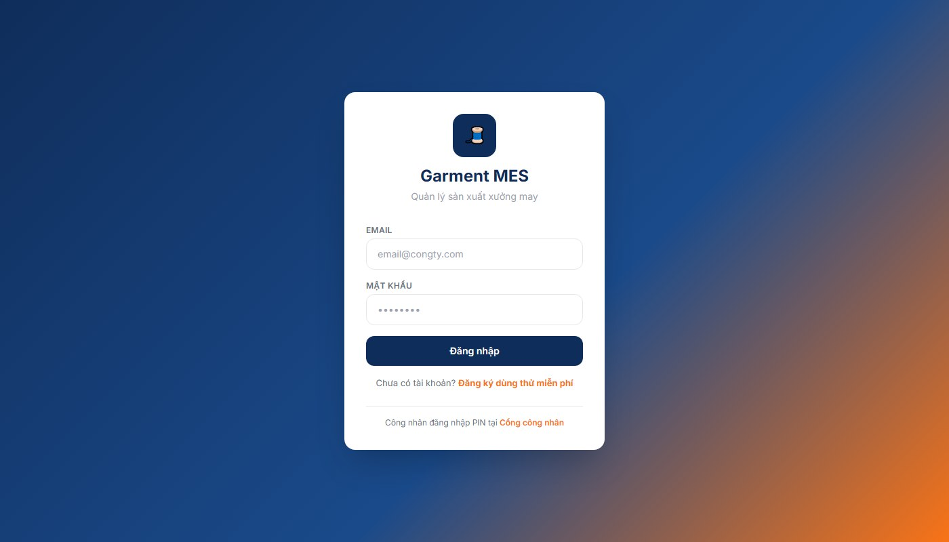
Hinh 2.1 - Trang dang nhap Garment MES
Buoc 1: Nhap Email va Mat khau duoc cap
Buoc 2: Nhan nut "Dang nhap"
Buoc 3: He thong chuyen den trang Tong quan sau khi xac thuc thanh cong
Luu y: O cuoi trang dang nhap co lien ket "Cong cong nhan" - day la cong rieng cho cong nhan su dung PIN.

2.2 Trang Tong quan (Dashboard)
Sau dang nhap, he thong hien thi trang Tong quan voi cac chi so quan trong:
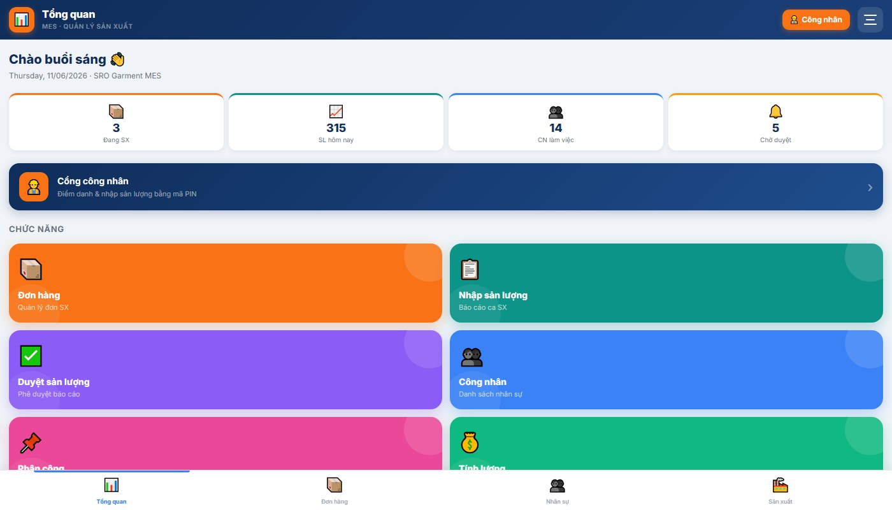
Hinh 2.2 - Trang Tong quan (Dashboard)
- Dang SX: So don hang dang trong qua trinh san xuat
- SL hom nay: Tong san luong bao cao hom nay toan xuong
- CN lam viec: So cong nhan dang co mat
- Cho duyet: So bao cao san luong chua duoc phe duyet

Meo: Banner xanh dam "Cong cong nhan" o giua trang - click de mo giao dien cho cong nhan su dung tren may tinh bang tai xuong.

CHUONG 3: QUAN LY DON HANG

3.1 Danh sach don hang
Tu Dashboard hoac menu duoi, click "Don hang". Trang hien thi tat ca don hang voi thanh loc theo trang thai.
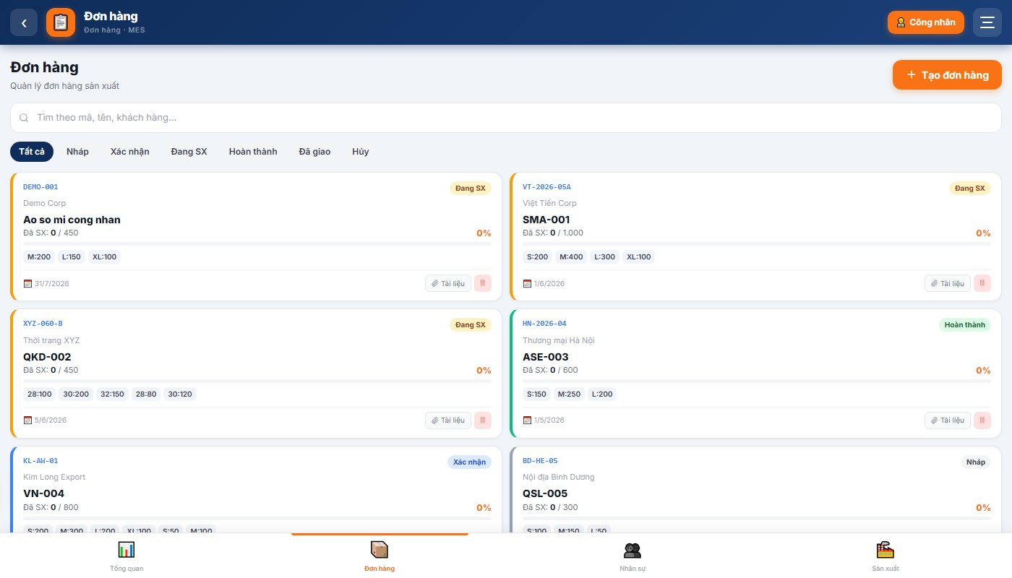
Hinh 3.1 - Danh sach don hang san xuat
Moi the don hang hien thi: ma don, trang thai, ten khach hang, style, tien do %, chi tiet kich co, ngay giao hang.

3.2 Tao don hang moi
Buoc 1: Click nut "+ Tao don hang" goc tren phai (mau cam)
Buoc 2: Dien day du: Ma don (duy nhat), Ten khach hang, Style san pham, So luong tung kich co S/M/L/XL, Ngay giao
Buoc 3: Nhan "Luu" de tao don hang
Luu y: Ma don hang phai la duy nhat trong he thong. Neu bao loi trung ma, doi ma va thu lai.

CHUONG 4: PHAN CONG CONG DOAN CHO CONG NHAN

4.1 Danh sach ke hoach san xuat
Tu Dashboard -> click "Phan cong". Man hinh hien thi danh sach ke hoach dang chay ben trai.
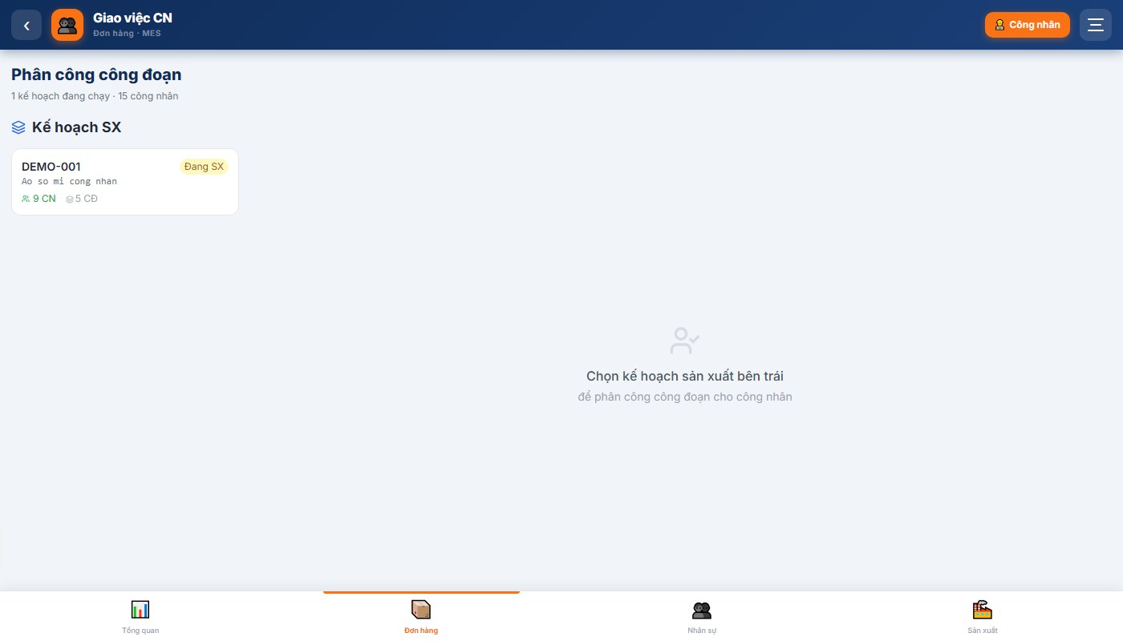
Hinh 4.1 - Danh sach ke hoach san xuat dang chay

4.2 Phan cong chi tiet cong doan
Click vao the ke hoach de xem va thuc hien phan cong:
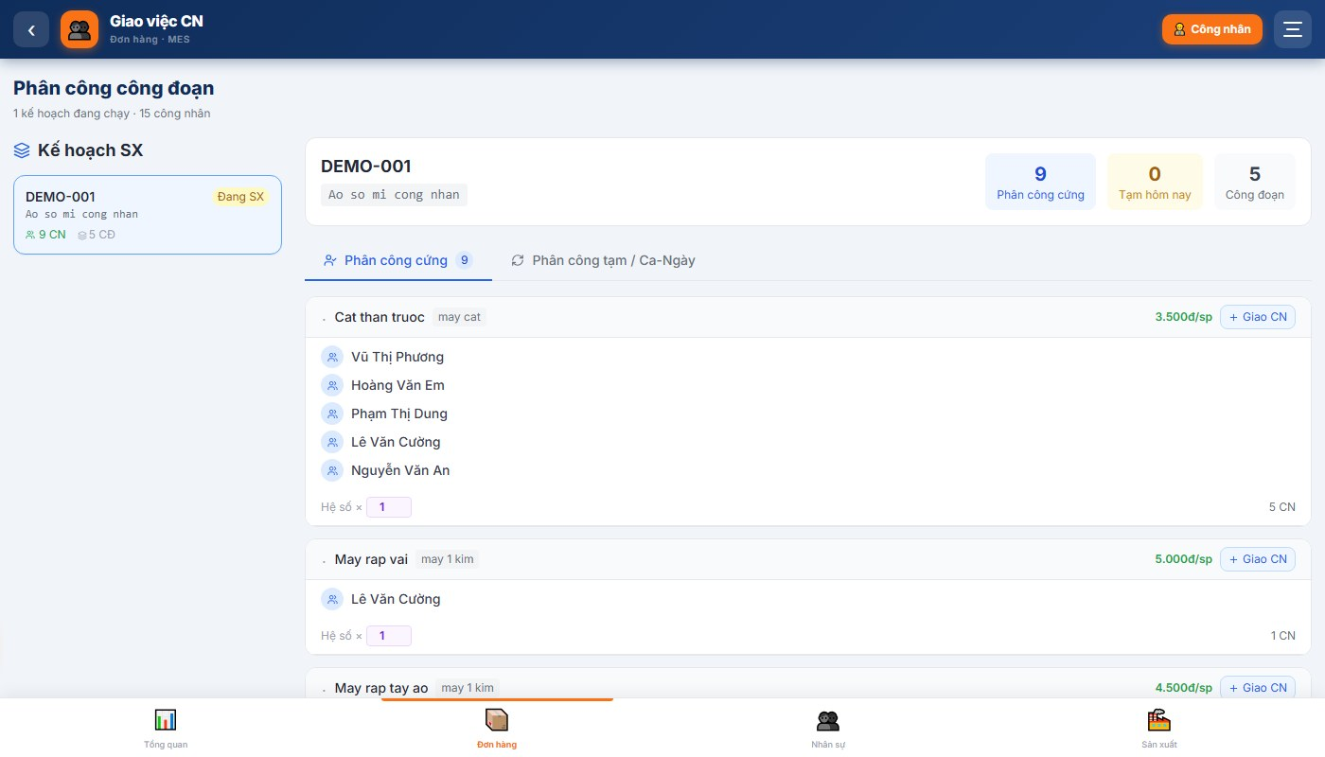
Hinh 4.2 - Phan cong chi tiet cac cong doan cho cong nhan
Buoc 1: Click vao ke hoach can phan cong (vi du: DEMO-001 - Ao so mi cong nhan)
Buoc 2: Man hinh chi tiet hien thi tung cong doan: Cat than truoc, May rap vai, May co ao...
Buoc 3: Voi moi cong doan, click "+ Giao CN" de them cong nhan vao cong doan do
Buoc 4: Chon cong nhan tu danh sach, dat He so (mac dinh 1.0)
Buoc 5: He thong tu luu. Cong nhan ngay thay cong viec trong Cong cong nhan
Luu y: He so nhan tinh luong: Luong = so_sp x don_gia x he_so. Cong viec kho (he so 2) duoc luong gap doi.

CHUONG 5: DUYET SAN LUONG

5.1 Man hinh duyet san luong
Tu Dashboard -> click "Duyet san luong" (mau tim). Hien thi danh sach bao cao san luong cua cong nhan.
Hinh 5.1 - Man hinh Duyet san luong
Buoc 1: Xem thong tin: ten cong nhan, cong doan, so luong, ngay bao, ca
Buoc 2: Click "Duyet" (mau xanh) de phe duyet - san luong duoc tinh vao luong
Buoc 3: Click "Tu choi" neu so lieu bat hop le, nhap ly do tu choi
Luu y: Chi bao cao co trang thai 'Da duyet' moi duoc tinh vao luong. Bao cao 'Cho duyet' chua duoc tinh.

CHUONG 6: TINH LUONG TU DONG

6.1 Man hinh tinh luong
Tu Dashboard -> click "Tinh luong" (mau xanh ngoc). Chon thang can tinh.
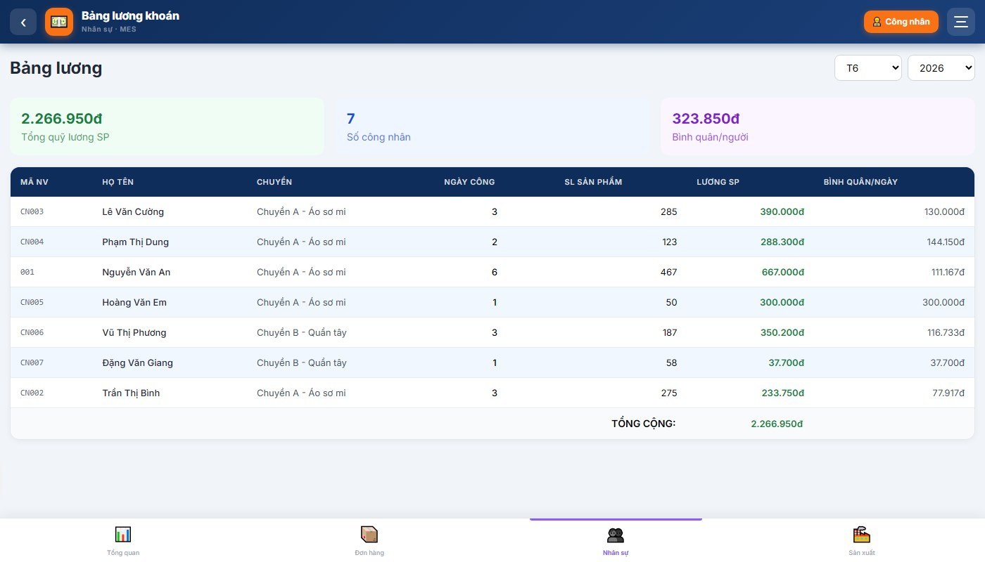
Hinh 6.1 - Man hinh Tinh luong tu dong
Cong thuc: Luong SP = Tong (so_luong x don_gia x he_so_nhan)
Thanh phan | Y nghia | Vi du
so_luong | SP bao & duoc duyet | 80 san pham
don_gia | Gia cong doan theo style | 3.500d/sp
he_so_nhan | He so phuc tap (mac dinh 1) | x1 hoac x2
=> Luong | Ket qua | 80 x 3.500 x 1 = 280.000d

Buoc 1: Chon thang can tinh luong
Buoc 2: Click "Tinh luong" - he thong tong hop tat ca SP da duyet trong thang
Buoc 3: Xem bang luong tung cong nhan, xuat Excel hoac in an
Luu y: Luong chi tinh san pham DA DUOC PHUYET DUYET. Bao cao chua duyet hoac bi tu choi khong duoc tinh.

CHUONG 7: QUAN LY NHAN SU

7.1 Danh sach cong nhan
Tu menu duoi, click "Nhan su". Hien thi toan bo cong nhan trong xuong, phan nhom theo chuyen.
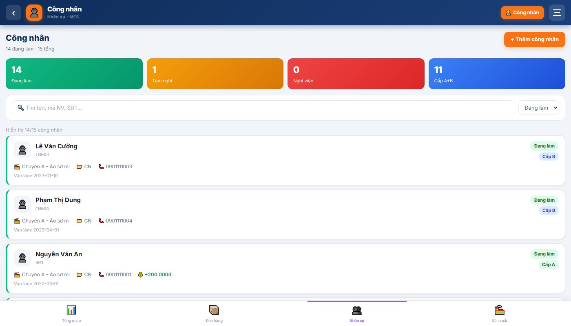
Hinh 7.1 - Danh sach cong nhan

7.2 Them cong nhan moi
Buoc 1: Click "+ Them cong nhan"
Buoc 2: Nhap: Ho ten, Ma NV (chi so, vi du: 001), Chuyen, PIN mac dinh (4 chu so)
Buoc 3: Click "Luu" - cong nhan co the dang nhap Cong cong nhan ngay
Luu y: Ma NV chi duoc dung SO (0-9). Vi du: nhap '001', khong phai 'CN001'.

7.3 Dat lai PIN cho cong nhan
Buoc 1: Tim cong nhan -> click "Sua"
Buoc 2: Nhap PIN moi 4 chu so -> click "Luu"
PIN moi co hieu luc ngay lap tuc.

CHUONG 8: CONG CONG NHAN - CONG NHAN TU BAO SAN LUONG

8.1 Gioi thieu
Day la tinh nang dac biet: cong nhan tu bao so san pham da lam hang ca truc tiep tu dien thoai tai xuong - khong can giay to, khong can quan ly nhap ho. Giao dien to chu, don gian, dang nhap bang PIN 4 so.
Dia chi: https://may1.qlsx.net/worker-portal

8.2 Buoc 1: Nhap Ma nha may
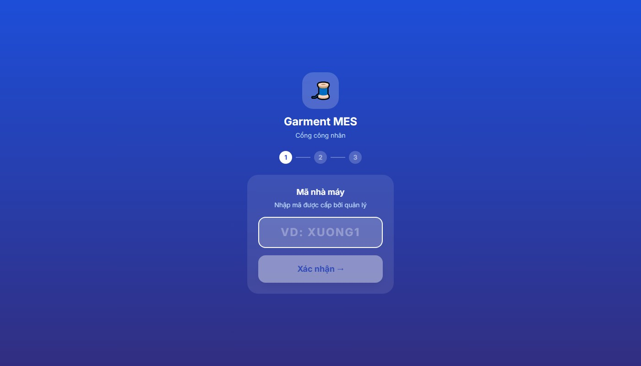
Hinh 8.1 - Buoc 1: Nhap ma nha may
Buoc 1: Nhap Ma nha may do quan ly xuong cung cap (vi du: DEMO1, XUONG1)
Buoc 2: Click "Xac nhan" - he thong hien thi ten xuong neu ma dung

8.3 Buoc 2: Nhap Ma so nhan vien
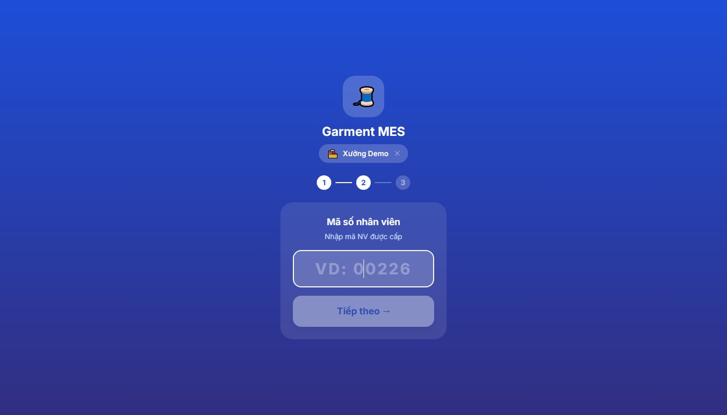
Hinh 8.2 - Buoc 2: Nhap ma so nhan vien
Buoc 1: Nhap ma so nhan vien (chi gom chu so, vi du: 001, 025)
Buoc 2: Click "Tiep theo"

8.4 Buoc 3: Nhap ma PIN
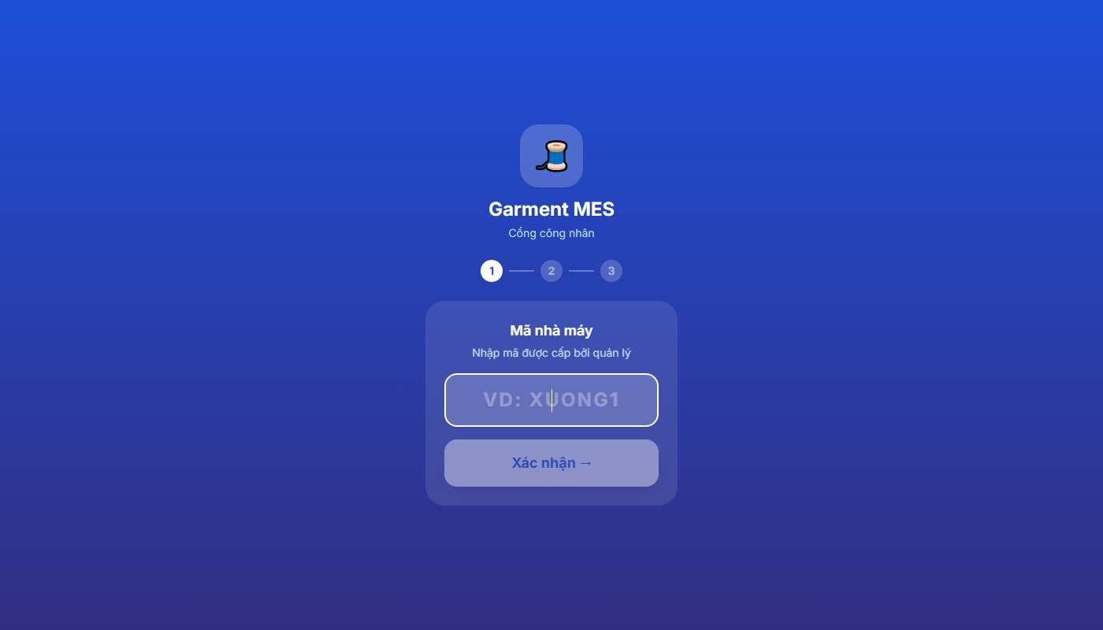
Hinh 8.3 - Buoc 3: Ban phim so nhap PIN
Buoc 1: Bam lan luot 4 chu so PIN tren ban phim ao
Buoc 2: He thong tu dong dang nhap sau khi nhap du 4 so
Buoc 3: Neu PIN sai: bam nut xoa (<<) va nhap lai
Bao mat: PIN la 4 chu so bi mat. Cong nhan nen doi PIN sau lan dang nhap dau. Neu quen PIN, lien he quan ly xuong.

8.5 Trang chu sau dang nhap
Hinh 8.4 - Trang chu cong nhan sau dang nhap
Man hinh hien thi: ten cong nhan, so sp da bao hom nay, tong tien luong SP, nut "Bao san luong ngay".

8.6 Bao cao san luong
Hinh 8.5 - Man hinh Bao cao san luong
Buoc 1: Click nut "Bao san luong ngay" (mau xanh to)
Buoc 2: Chon Ca lam viec: Ca sang (6-14h) hoac Ca chieu (14-22h)
Buoc 3: Chon Don hang dang san xuat
Buoc 4: Nhap So luong san pham da hoan thanh trong ca
Buoc 5: Click "Gui bao cao"
Bao cao se co trang thai 'Cho duyet'. Khi quan ly phe duyet -> 'Da duyet' va tien luong duoc cong vao.

PHU LUC A: BANG CONG DOAN VA DON GIA MAU
Vi du bang cong doan cho style 'Ao so mi cong nhan':
STT | Cong doan | Loai may | Don gia | He so | Ghi chu
1 | Cat than truoc | May cat | 3.500d/sp | x1
2 | May rap vai | May 1 kim | 5.000d/sp | x1
3 | May rap tay ao | May 1 kim | 4.500d/sp | x2 | Cong viec kho
4 | May co ao | May 1 kim | 6.000d/sp | x1
5 | La - Gap - Dong goi | Ban la | 4.000d/sp | x1

PHU LUC B: LIEN HE HO TRO
- Email: admin@sroviet.net
- He thong: https://may1.qlsx.net
- Ho tro: dao tao su dung, nhap du lieu ban dau, xu ly su co

--- HET TAI LIEU ---
Garment MES v2.0 | SRO Viet Nam | may1.qlsx.net

